STRATEGIC WORKFORCE ANALYTICS AND ATTRITION INSIGHTS
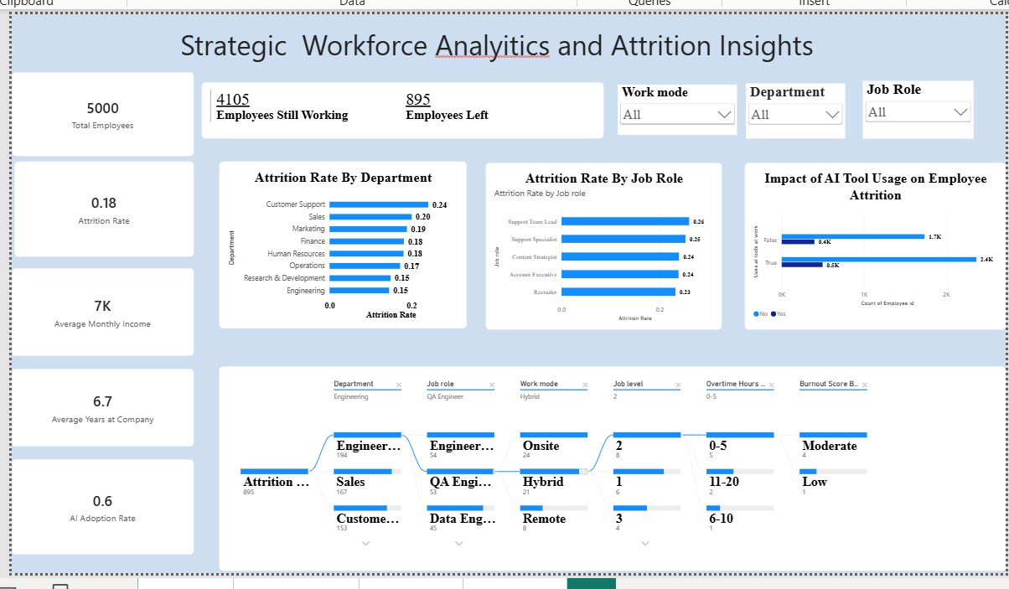
- Dashboard Report

Dashboard Overview
  - The Strategic Workforce Analytics and Attrition Insights dashboard is created in Microsoft Power BI to analyse employee workforce information and attrition. It presents key performance indicators, department-wise attrition, job-role-wise attrition, and the impact of AI tool usage on employee attrition. The dashboard also provides interactive filters for detailed analysis.
  - Key Performance Indicators KPI Displayed Value Total Employees 5,000 Employees Still Working 4,105 Employees Left 895 Attrition Rate 0.18 Average Monthly Income 7K Average Years at Company 6.7 AI Adoption Rate 0.6
  - Attrition Rate by Department The dashboard displays attrition rates for the following departments: Department Attrition Rate Customer Support 0.24 Sales
0.20 Marketing 0.19 Finance 0.18 Human Resources 0.18 Operations 0.17 Research
C Development 0.15 Engineering 0.15
  - Attrition Rate by Job Role The dashboard contains a bar chart for Attrition Rate by Job Role. It enables comparison of attrition rates across the job roles shown in the dashboard, including Support Team Lead, Support Specialist, Content Specialist, Account Executive, and Recruiter.
  - Impact of AI Tool Usage on Employee Attrition The dashboard includes a visual titled Impact of AI Tool Usage on Employee Attrition. It compares employee attrition

according to AI tool usage and supports analysis of the relationship between AI adoption and employee attrition.
  - Interactive Filters and Workforce Details The dashboard provides filters for Work Mode, Department, and Job Role. The lower section also provides employee-related categories including Department, Job Role, Work Mode, Job Level, Overtime Hours, and Burnout Score. These controls help users explore selected groups of employees.
  - Dashboard Purpose • To provide a clear summary of employee workforce information. • To monitor employees who are still working and employees who have left. • To compare attrition rates across departments and job roles. • To examine AI tool usage in relation to employee attrition. • To support interactive analysis using employee-related filters.
  - Conclusion The Strategic Workforce Analytics and Attrition Insights dashboard provides an interactive Power BI view of employee workforce and attrition information. By combining KPI cards, department-wise and job-role-wise charts, AI tool usage analysis, and interactive filters, the dashboard converts employee data into useful visual information for workforce analysis.

